

Rapid Controller
Setup Guide

Prepared by: Rapid Solutions and Consulting LLC
Last Updated: December 16, 2015

Table of Contents

1. Introduction 3
2. Installation 4
1. NoVNC 4
2. Panopticon 4
3. Configure 5
1. Observed Hosts 5
2. Panopticon 6
3. HTTPD 7
4. Firewall 7
3. Start Services 8
1. NoVNC 8
2. Panopticon 8
3. HTTPD 8
3. View Rapid Controller 9

1. Introduction
Rapid Controller allows users to monitor, find and control Rapid Client sessions from a central web interface. With the availability of Rapid Client Appliance and the ability to setup and use multiple sessions on a single Appliance, users can now control hundreds of appliance sessions from their web browser on any computer.

This document is going to guide the users to setup and use the Rapid Controller on their environments.

2. Installation

. NoVNC
Install NoVNC
[res@rapidclienttest03]$ cd /opt
[res@rapidclienttest03 opt]$ git clone git://github.com/kanaka/noVNC

Create self signed SSL certificate.
[res@rapidclienttest03 opt]$ cd noVNC
[res@rapidclienttest03 noVNC]$ openssl req -new -x509 -days 365 -nodes -out selfSingedCert.pem -keyout selfSignedCert.pem

Create NoVNC Auto Start Script
[res@rapidclienttest03 opt]$ cd ~
[res@rapidclienttest03 opt]$ vi .kde/AutoStart/novnc_starter.sh

Add the following commands in the script.
cd /opt/noVNC
nohup ./utils/launch.sh --vnc localhost:5901 --listen 6081 --cert selfSignedCert.pem &

. Panopticon
Download and unzip the latest Rapid Client build and copy the following files and folders to /opt/res/panopticon
[res@rapidclienttest03 ~]# mkdir /opt/res/panopticon

[res@rapidclienttest03 ~]# cp html/ observed.hosts.properties observed.html panopticon.jar panopticon.properties runPanopticon.sh /opt/res/panopticon/

[res@rapidclienttest03 res]$ ls /opt/res/panopticon

html observed.hosts.properties observed.html panopticon.jar panopticon.properties runPanopticon.sh
Checkout Panopticond service from SVN
[res@rapidclienttest03 ~]# svn co http://svn01.rapidesuite.com:999/svn/a/IT/appliance/etc/init.d/panopticond
Copy the service to init.d
[root@rapidclienttest03 ~]# cp ./panopticond /etc/init.d/

[root@rapidclienttest03 ~]# chkconfig --add panopticond

3. Configure

1. Observed Hosts
Open and edit the “/opt/res/panopticon/observed.hosts.properties” file to specify the client hosts that the Rapid Controller should moniter
###########################################
# This file is lists all remove hosts that should be observed via VNC and displayed on Intraweb
#
# Line Format:
# displayname=hostname,vncport,vncpassword,websockifyport
# Example:
# pc-spare01.rapidesuite.com:5900=pc-spare01.rapidesuite.com,5900,dbasupport,6080
#
# Note: The order these appear in the HTML output is the order listed in this file.

RapidClient01.rapidesuite.com:5901=RapidClient01.rapidesuite.com,5901,dbasupport,6081
RapidClient01.rapidesuite.com:5902=RapidClient01.rapidesuite.com,5902,dbasupport,6082
RapidClient01.rapidesuite.com:5903=RapidClient01.rapidesuite.com,5903,dbasupport,6083
RapidClient01.rapidesuite.com:5904=RapidClient01.rapidesuite.com,5904,dbasupport,6084
RapidClient01.rapidesuite.com:5905=RapidClient01.rapidesuite.com,5905,dbasupport,6085
RapidClient01.rapidesuite.com:5906=RapidClient01.rapidesuite.com,5906,dbasupport,6086

2. Panopticon
Panopticon properties
The default properties should work out of the box, but if changed behaviour is required edit the “/opt/res/panopticon/panopticon.properties” file to configure panopticon.
# fetch screenshot interval
displayHTMLrefreshIntervalInSeconds=30
# path to the hosts to observer properties file
pathToObservedHostsFile=observed.hosts.properties
# screen capture dimension
screenCaptureDimensions=256x205
# number of screenshots per row in the html
screenCaptureCountPerRow=3
# output html file name
observedHostsOutputFileName=observed.shtml
# output html table file name
observedHostsOutputTableFileName=observedTable.shtml
# template (input) html file name
observedHostsInputFileName=observed.html
# use noVNC?
useNoVNCClient=true
# use noVNC in auto mode
noVNCAutoMode=false
# provide the password automatically to noVNC?
noVNCAutoPassword=false
# use SSL connection between the noVNC client and the websockify proxy server
noVNCUseSSLforConnection=true
# ping the vnc host before going into to capture the screenshot
# it is linux only feature, therefore configured through property.
# necessary because of TightVNC memory leak that manifests when trying to connect to an unreacable host.
pingHostBeforeCaptureScreen=false
# show error message if all appliance sessions are offline
allSessionsOfflineMessage=All connections are offline. If you continue view this message for more than 10 minutes please contact your System Administrator

3. HTTPD
HTML Output
Configure HTTPD (Apache) to render panopticon output files.
[root@rapidclienttest03 ~]# rm -rf /var/www/html/

[root@rapidclienttest03 ~]$ ln -s /opt/res/panopticon/html /var/www/

[root@rapidclienttest03 ~]# usermod -a -G res apache

[root@rapidclienttest03 ~]# chkconfig httpd on

[root@rapidclienttest03 ~]# service httpd start

Enable Server Side Includes (SSI)
Modify the following directive in the httpd.conf (/etc/httpd/conf/httpd.conf)
- Options Indexes FollowSymLinks
To
- Options Indexes FollowSymLinks + Includes

Add the following directive in the httpd.conf (/etc/httpd/conf/httpd.conf)
- XBitHack on

#
# Possible values for the Options directive are "None", "All",
# or any combination of:
# Indexes Includes FollowSymLinks SymLinksifOwnerMatch ExecCGI MultiViews
#
# Note that "MultiViews" must be named *explicitly* --- "Options All"
# doesn't give it to you.
#
# The Options directive is both complicated and important. Please see
# http://httpd.apache.org/docs/2.2/mod/core.html#options
# for more information.
#
Options Indexes FollowSymLinks +Includes
XBitHack on

Modify DirectoryIndex
Modify the following directive in the httpd.conf (/etc/httpd/conf/httpd.conf)
- DirectoryIndex index.html index.html.var
To
- DirectoryIndex index.html index.html.var observed.shtml

#
# DirectoryIndex: sets the file that Apache will serve if a directory
# is requested.
#
# The index.html.var file (a type-map) is used to deliver content-
# negotiated documents. The MultiViews Option can be used for the
# same purpose, but it is much slower.
#
DirectoryIndex index.html index.html.var observed.shtml
Add FilesMatch
Add the following directive in the httpd.conf (/etc/httpd/conf/httpd.conf)
- <FilesMatch "\.(png|jpg|jpeg|jpeg)$">
Header set Expires "Fri, 04 Aug 1978 12:00:00 GMT"
Header set Cache-Control "no-cache, no-store, must-revalidate, max-age=0, proxy-revalidate, no-transform"
Header set Pragma "no-cache"
</FilesMatch>

<FilesMatch "\.(png|jpg|jpeg|jpeg)$">
Header set Expires "Fri, 04 Aug 1978 12:00:00 GMT"
Header set Cache-Control "no-cache, no-store, must-revalidate, max-age=0, proxy-revalidate, no-transform"
Header set Pragma "no-cache"
</FilesMatch>

4. Firewall
Firewall Exception for HTTPD
Add exception in Firewall to allow port 80 connections for HTTPD
[root@rapidclienttest03 ~]# /sbin/iptables -A INPUT -m state --state NEW -p tcp --dport 80 -j ACCEPT

[root@rapidclienttest03 ~]# /sbin/service iptables save

[root@rapidclienttest03 ~]# service iptables restart

3. Start Services

1. NoVNC
Start the No VNC
[root@rapidclienttest03 ~]# .kde/AutoStart/novnc_starter.sh

2. Panopticon
Start the Panopticon service
[root@rapidclienttest03 ~]# .service panopticond start

3. HTTPD
Start the Apache Web Server
[root@rapidclienttest03 ~]# .service httpd start

3. View Rapid Controller
Open the link to Rapid Controller in your browser
http://<domain>/observed.shtml

If all the setup is done correctly you should be able to view the following Rapid Controller page

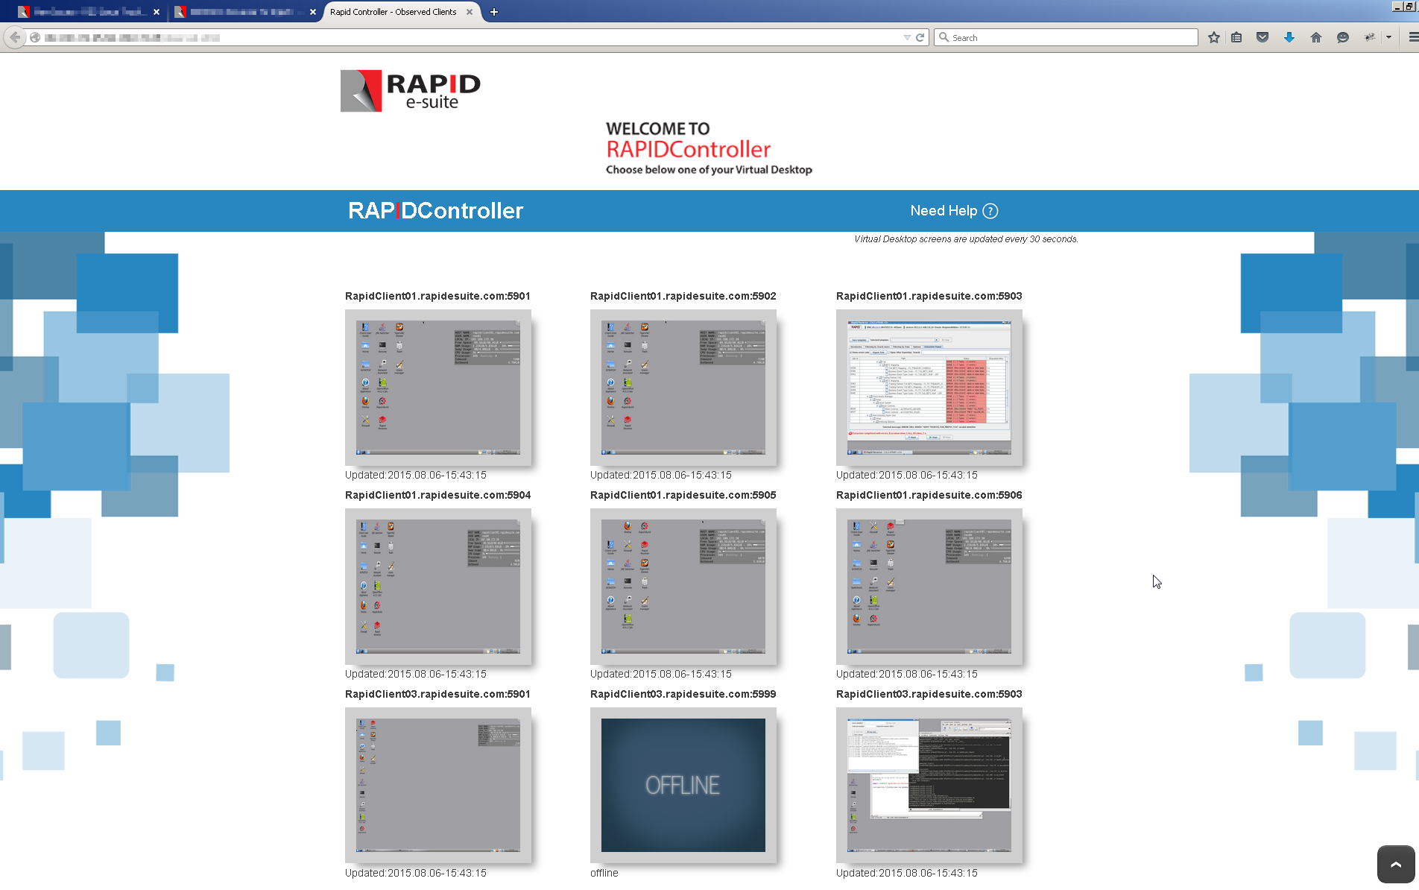

If at first you see the Rapid Client Sessions as offline, please wait and let Rapid Controller connect to the Client sessions.

